|  |  |
| --- | --- |
|  | **2022** |
|  |  |

ASSIGNMENT

Name: Muhammad Diyan Irfan

Course: BSCS-6

Subject: WP

MIS ID: 28396

Date: 20 June, 2022

Q1: Add element in HTML using JavaScript.

Code:

<! Doctype html>

<Html>

<Body>

<h2>JavaScript HTML DOM</h2>

<p>add a new HTML element</p>

<div id="div1">

<p id="p1">this is a paragraph</p>

<p id="p2">this is another paragraph</p>

</div>

<Script>

Const para=document.createelement ("p");

Const node=document.createtextnode ("This is new.");

para.appendchild (node);

Const element=document.getelementbyid ("div1");

Const child=document.getelementbyid ("p1");

element.insertbefore (para, child);

</script>

</body>

</html>

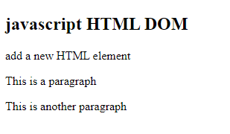

Q2: Remove element in HTML using JavaScript:

Code:

<!DOCT>YPE html>

<html>

<head>

<h1>Removing an element</h1>

<p id="para">click"remove",and this particular element will be removed</p>

<button onclick="myfunction()">remove</button>

<script>

function myfunction()

{

const element=document.getelementbyid("para");

element.remove();

}

</script>

</body>

</html>

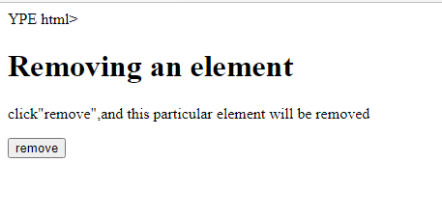

Q3: Show a time delay while loading a Dom file.

Code:

<!DOCTYPE html>

<html>

<body>

<h2>javascript HTML DOM</h2>

<p id="intro">Time delay while loading file</p>

<p id="demo"></p>

<button onclick="setTimeout(myfunction,3000);">try it</button>

<script>

function myfunction()

{

document.getelementbyid("demo")innerHTML ="Some text here";

}

</script>

</body>

</html>

